|  |  |  |  |  |  |  |  |  |  |  |  |  |  |  |  |  |  |  |
| --- | --- | --- | --- | --- | --- | --- | --- | --- | --- | --- | --- | --- | --- | --- | --- | --- | --- | --- |
| **INTERSTATE CONTAINER CORPORATION** | | ***Date:* 04/11/2017** | ***Spec #:*** | | | | | | | | | | ***Design #:*60764-01_G** | | | |  |  |
|  |  |
| ***Customer:* DeMet's Candy** |  |  |  |  |  |  |  |  |  |  |  |  |  |  |  |  |  |  |
|  |  |  |  |  |  |  |  |  |  |  |  |  | ***Cut*** | **132 in.** | |  |  |
|  |  |  |  |  |  |  |  |  |  |  |  |  |  |  |
| ***Description:* 6/5oz. Caddy - 9935/0 [Left-Hand 1/8" Gap]** | |  |  |  |  |  |  |  |  |  |  |  |  |  |  |
|  |  |  |  |  |  |  |  |  |  |  |  | ***Crease*** | **103 in.** | |  |  |
|  |  |  |  |  |  |  |  |  |  |  |  |  |  |
| ***Style:* RSC** | ***Revision Info:* [G]04/11/2017:[LEFT HAND 1/8"GAP]** | |  |  |  |  |  |  |  |  |  |  |  |  |  |
|  |  |  |  |  |  |  |  |  |  |  |  |  |  |  |  |
|  |  |  |  |  |  |  |  |  |  |  |  |  |  |  |  |
| ***I.D. :* 12+1/2 x 5+1/4 x 8** | ***Blank size:* 13+3/8 x 37+1/4** |  |  |  |  |  |  |  |  |  |  |  |  |  |  |  |  |  |
|  |  |  |  |  |  |  |  |  |  |  |  |  |  |  |  |  |
| ***Board:* 32 B K** | ***Combination:* 35HP - 23M - 35HP** | ***Designer:* Alan Groff** |  |  |  |  |  |  |  |  |  |  |  |  |  |  |  |  |
|  |  |  |  |  |  |  |  |  |  |  |  |  |  |  |  |

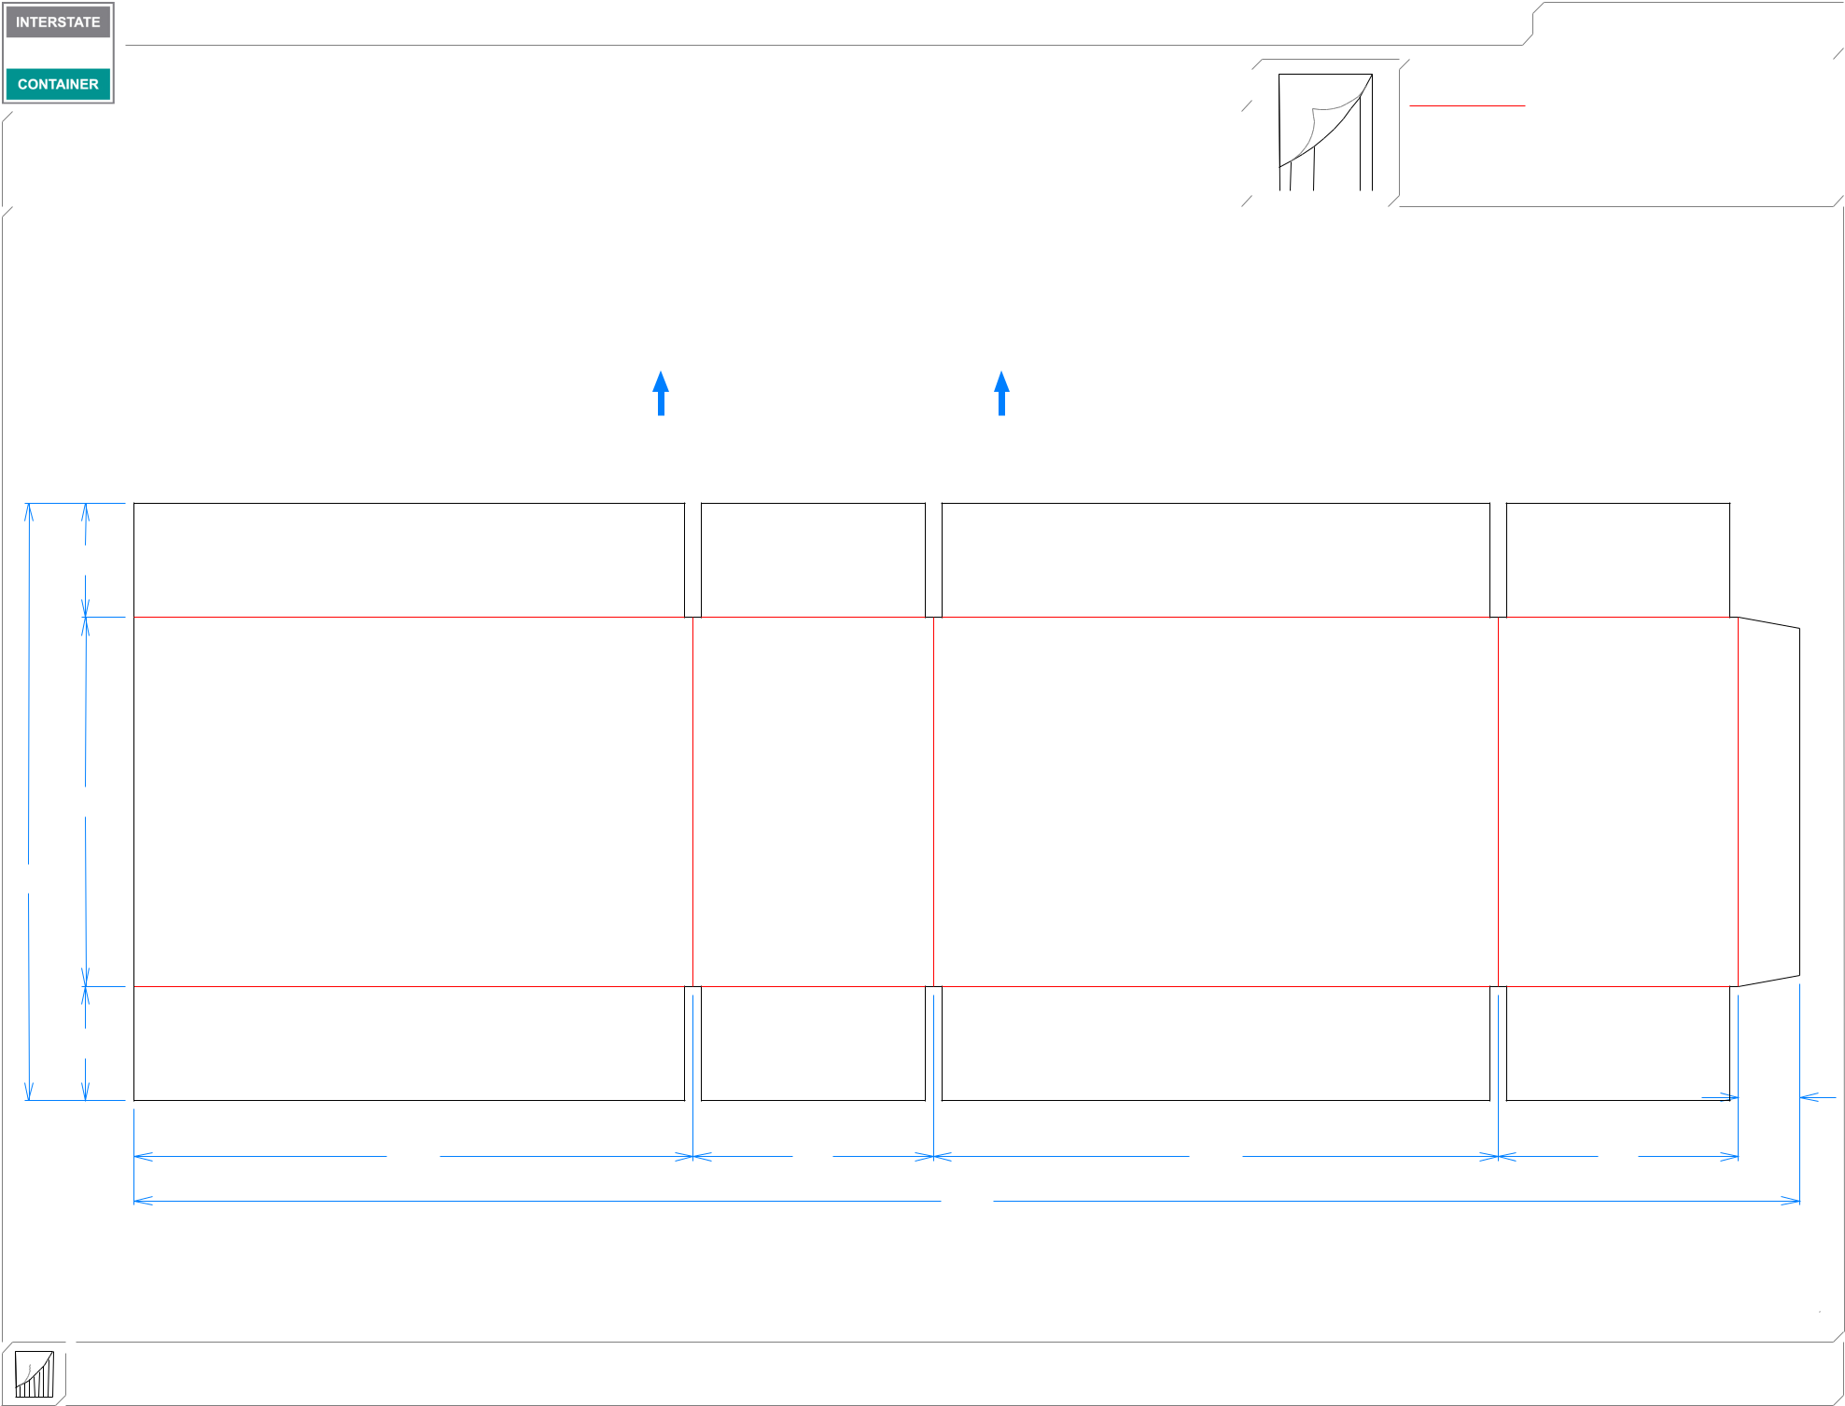

**MINI FFG**

**LEAD EDGE**

29*/*16

81*/*4

133*/*8

29*/*16

13*/*8

|  |  |  |  |
| --- | --- | --- | --- |
| 121*/*2 | 53*/*8 | 125*/*8 | 53*/*8 |
|  |  | 371*/*4 |  |

**inside view**

**Vertical Corrugation**

***notes:***

***Qty/unit:*** ***Area - waste:* 3.36 sq. ft** ***Waste on blank:* 2.8%** ***Piece weight - waste:* 0.35 lbs./157.25 g**